Team GreenTech

PROJECT #1

REPORT

REPORT



Adoption trends for Rooftop Solar in New York State

Produced By:

* Josh B.
* Dispeh
* Vish
* Aubrey

Table of Contents

1 Introduction 3

2 Research Questions 3

3 Data sources and methodology 4

4 Results 6

4.1 What is the penetration of solar and is it still growing? Are Adoption Trends for Residential and Commercial Customers Different? 6

4.2 How does solar adoption vary by location? Is it concentrated in specific locations? 7

4.3 How have the costs of solar changed over time? with and without incentives? 9

4.4 How do solar adopters finance solar? Do they buy solar, lease it, or use a different financial arrangement? 10

4.5 How are income levels related to solar penetration and how solar is financed? 11

5 Key Findings 12

Figures

Figure 1: Methodology 5

Figure 2: Number of Solar Installation Projects Over Time 6

Figure 3: Rooftop Solar Output Capacity Over Time 7

Figure 4: Solar Adoption per Thousand People - Heat Map Layer Approach 7

Figure 5: Solar Adoption per Thousand People - Symbol Layer Approach 8

Figure 6: Solar Adoption per Thousand People - Choropleth Map Approach 8

Figure 7: Solar Costs ($/Watt) Over Time - Includes Installation and Equipment 10

Figure 8: Incentives as Share of Total Costs Over Time 10

Figure 9: Solar Installation by Type of Financial Arrangement 11

Figure 10: Adoption by Income Levels and Finance Type 12

Tables

Table 1: Key Research Questions 4

Table 2: Data Sources 5

Table 3: Research Questions and Key Findings 13

# Introduction

In the past decade, interest in distributed solar – typically installed in rooftops – has grown rapidly. Several states adopted policies to help accelerate the adoption of rooftop, introducing incentives to drive down customer out-of-pocket costs of installing rooftop solar. In addition, there have been several financial innovations introduced to lower upfront costs of solar, which historically has been a barrier to solar adoption. The innovations include zero-down leasing options and no-purchase models.

The result has been an accelerated rate of solar adoption in the past five or so years, but the adoption of solar appears to be slowing down. Most of the focus has been on residential for solar adoption rather than commercial adoption. In this analysis, our goal was to explore and visualize rooftop solar adoption trends in New York state and assess if specific segments and geographic locations are experiencing growth or higher adoption rates.

# Research Questions

**Error! Reference source not found.** summarizes the key research questions of the assessment. For clarity, the research questions were bifurcated into analyses of adoption trends and analysis of economic and financial trends related to customer adoption.

Table 1: Key Research Questions

|  |  |  |  |  |
| --- | --- | --- | --- | --- |
|  | |  | | Research Question |
| Adoption Trends | **1** | | What is the penetration of solar and is it still growing? Are adoption trends for residential and commercial customers different? | |
| **2** | | How do solar adoption rates vary by location? Is solar more concentrated in specific locations? | |
| Economic and Financial Trends | **3** | | How have the costs of solar changed over time? with and without incentives? | |
| **4** | | How do solar adopters finance solar? Do they buy solar, lease it, or use a different financial arrangement? | |
| **5** | | How are income levels related to solar penetration? | |

# Data sources and methodology

Table 2 summarizes the data sources employed in the assessment. New York has been at the forefront of the open government data movement. They publicly post and update datasets for a host of factors on their API. One of the datasets contained detailed information about each of roughly 83,700 rooftop solar projects (and growing), including when the project was completed, the project costs, the amount of incentives and rebates paid, how much solar was installed, expected energy production, and details about the installer and installation. The data is available for each individual project since 2000 and is updated to the API on a monthly basis. While the dataset included details for each individual solar installation, the exact location of the projects is not included to protect customer confidentiality. However, the dataset provides details regarding the county, city, and zip code were the rooftop solar was installed, enabling geographic analysis.

Table : Data Sources

| Data | Source | Information included | Use |
| --- | --- | --- | --- |
| Solar installation data 2000 to 2018 | https://data.ny.gov/api | * 83,7000 solar installation projects from 2000 to 2018, including:   + Project completion date   + Total project costs   + Incentives and rebates paid   + How much solar was installed   + Expected energy production   + Details about the installer and installations   + How the buyers financed solar (purchase type)   + County, city, and zip code of installation   + Other columns | * Explore adoption trends and financial cost trends over time * Identify where solar adoption is concentrated |
| Zip code level demographics | https://www.census.gov/data/developers/data-sets/acs-1year.2016.html | * Data for over 1,000 New York zip codes, including:   + Population   + Income level   + Education   + Various socio-economic data | * Calculate adoption per capita for zip codes * Explore relationship between income levels and adoption |
| Zip code polygons | https://www.census.gov/geo/maps-data/data/cbf/cbf_zcta.html | * Boundary file polygons for each zip code in New York | * Visualize the concentration of solar by zip code |
| NY electric demand hourly data | https://www.eia.gov/opendata/ | * New York hourly electricity demand including:   + Date   + Hour   + Electric Demand (MW) | * Data was not used because only 2.5 years was available and did not match study period |
| Weather data | http://api.openweathermap.org/data/2.5/weather | * Historical weather station, including:   + Weather station   + Lat/long of station   + Date   + Hour   + Temperature F   + Humidity   + Wind   + Cloud cover | * Data was not used because of costs – over $900 to download data for the study period. |

Figure 1 summarizes the methodology for the market assessment. The data was independently downloaded from the respective APIs, converted into data frames and standardized. This allowed us to merge the solar adoption and census data and create the main analysis dataset. To produce the various analyses, the data had to grouped and key metrics needed to be calculated at different levels of granularity. Because the data included both cross-sectional, spatial, and time series data, it provided a rich dataset for analysis of different dimensions.

Figure : Methodology

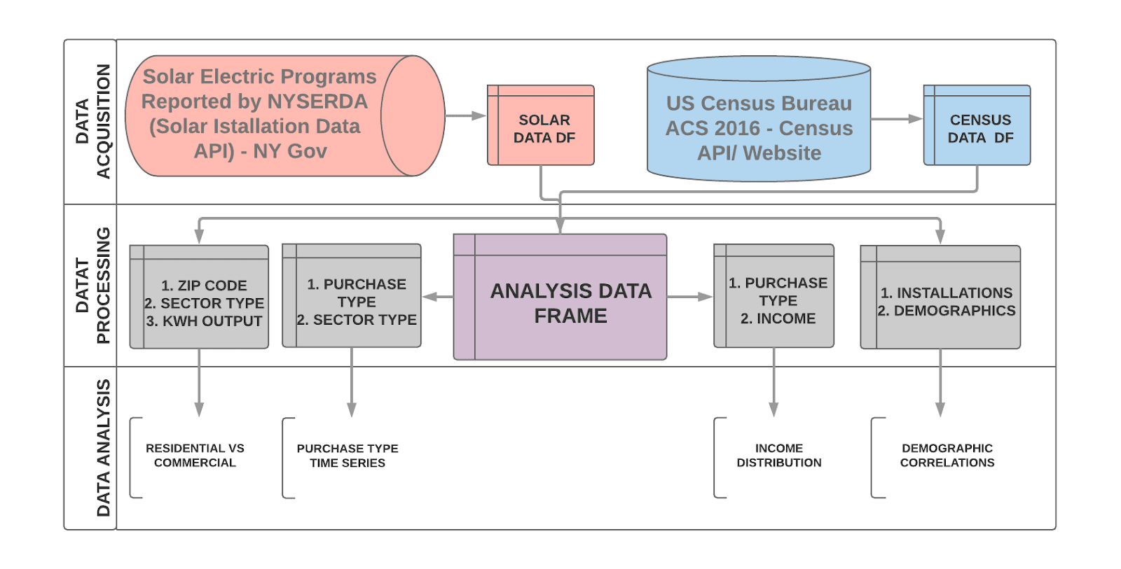

# Results

For clarity, the results are presented separately for each research question outlined. For each section, we visualize results an include a brief discussion about key observations.

## What is the penetration of solar and is it still growing? Are Adoption Trends for Residential and Commercial Customers Different?

Figure 2 and Figure 3 show the number of solar installations and the magnitude of those installations (solar capacity), respectively, for each month from 2000 to 2018. The plots differentiate between residential and commercial installations. The growth in solar installations was slow until 2013 or 2014 when the number of installations and total amount of solar installed started to expand rapidly. The rate of residential solar installations peaked in early 2016 and has since slowed down.

A key observation is that the number of installations does not correspond with outcome capacity, especially for commercial customers. Commercial installations are diminutive in number compared residential installations. However, when we consider the amount of solar installed commercial installations rival those on residential rooftops and, more importantly, show continued expansion and accelerating growth rates. This indicates a need to shift the focus from residential customers – most who want solar in New York have already installed it – to commercial customers.

Figure : Number of Solar Installation Projects Over Time

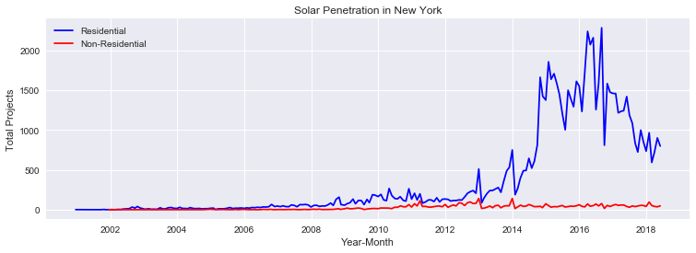

Figure : Rooftop Solar Output Capacity Over Time

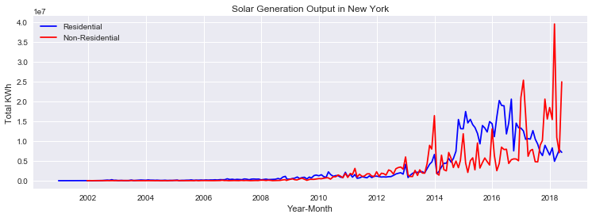

## How does solar adoption vary by location? Is it concentrated in specific locations?

A key question was whether rooftop solar adoption is concentrated in specific geographic locations. To distinguish between higher and lower population regions, solar adoption was calculated on per capita basis by dividing the capacity of the solar panels installed in each zip code by the population (in thousands) in the zip code. This produced data on solar adoption per 1,000 people by zip code. There were still some large disparities that appeared to be legitimate outliers. To better visualize the results, the zip codes were ranked according to percentile of solar adoption per 1000 people. Three different visualizations were attempted – a heat layer, an interactive symbol layer plot and an interactive choropleth map.

Figure : Solar Adoption per Thousand People - Heat Map Layer Approach

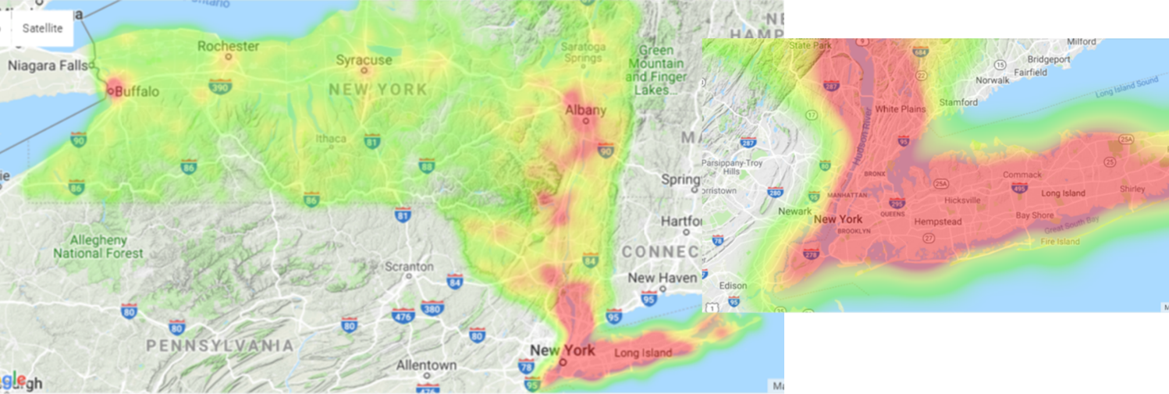

The heat map did not produce insights for the solar adoption data. It mirrored locations were the population was concentrated, with little nuance as to which zip codes had higher rates of adoption. Because highly populated areas are mode dense, the heat maps blended together areas close to each other without distinguishing areas with higher penetration (despite the weights).

Figure : Solar Adoption per Thousand People - Symbol Layer Approach

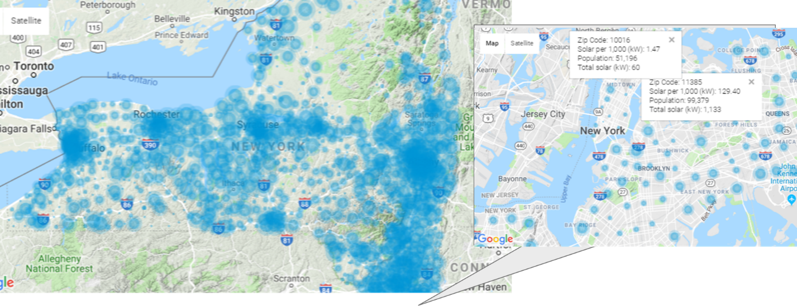

The symbol layer was a significant improvement. It showed the per capita solar adoption by using different circle sizes. While it also was denser in high population areas, zooming in allowed us to identify lower penetration in Manhattan versus Staten Island, for example. In addition, the method allowed us to include an interactive layer with popups that provided key information a for the zip code.

Figure : Solar Adoption per Thousand People - Choropleth Map Approach

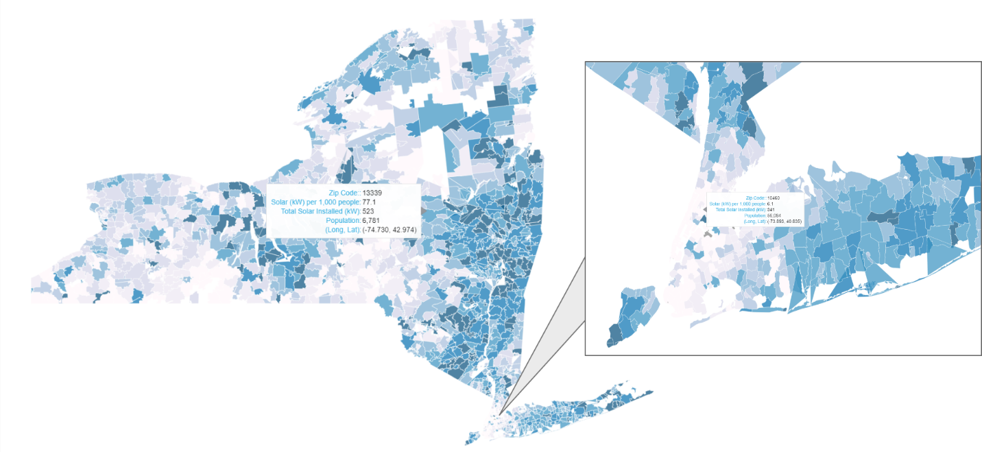

The best visualization of the geographic per capita adoption rates was an interactive choropleth map, using the Bokeh Python library. Choropleth maps shade different geographic areas defined by boundaries, such as zip codes, with different color hues based on the metric of interest – in this case, per capita solar. The Python module used also produced an interactive web-enabled plot (an html file) that provided users information about each location when their pointer hovered over a location. In addition, the user could zoom in, scroll, and save the file. The map clearly showed the areas of highest per capita adoption were location in the Hudson Valley – the area between New York City and Albany (inclusive) – Long Island, and the strip between Ithaca and Syracuse. Somewhat surprisingly, high income areas in New York City, such as Manhattan, had very low per capita adoption rates. The results, however, make sense when one considers the limited roof space and lower home ownership rates.

## How have the costs of solar changed over time? with and without incentives?

A key driver of solar adoption is cost. The most typical ways to represent costs is in dollars per watt ($/watt), defined as the total project costs divided the by production capability of solar installed. New York, however, included government sponsored incentives/rebates which reduced the actual cost customers paid. Figure 7 and Figure 8 show the how the actual costs of solar changed over time and how incentives/discounts changed as share of total projects costs over time. When solar was first introduced costs were high but incentives/rebates covered a substantial share of costs. As the cost of solar dropped, the share of total project costs paid through incentives/rebates also decreased. The decrease in costs, however, was continuous and preceded the rapid expansion of rooftop solar.

Figure : Solar Costs ($/Watt) Over Time - Includes Installation and Equipment

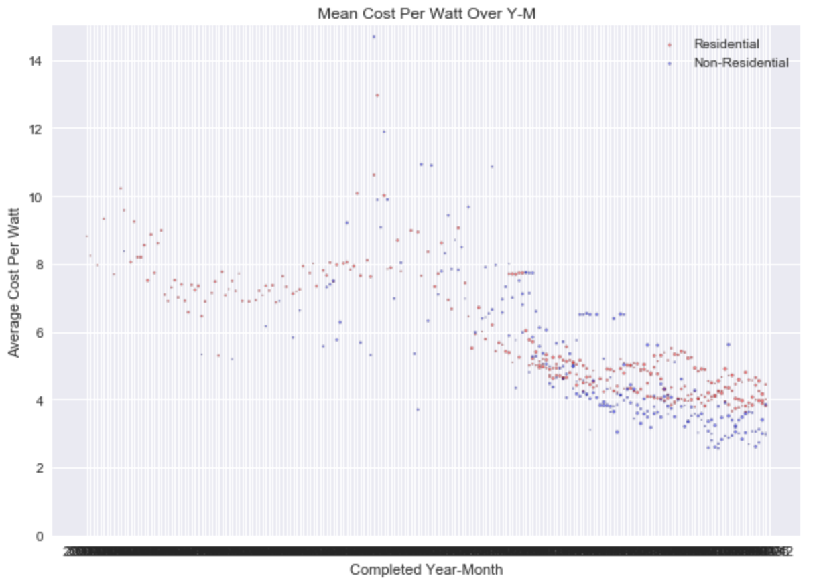

Figure : Incentives as Share of Total Costs Over Time

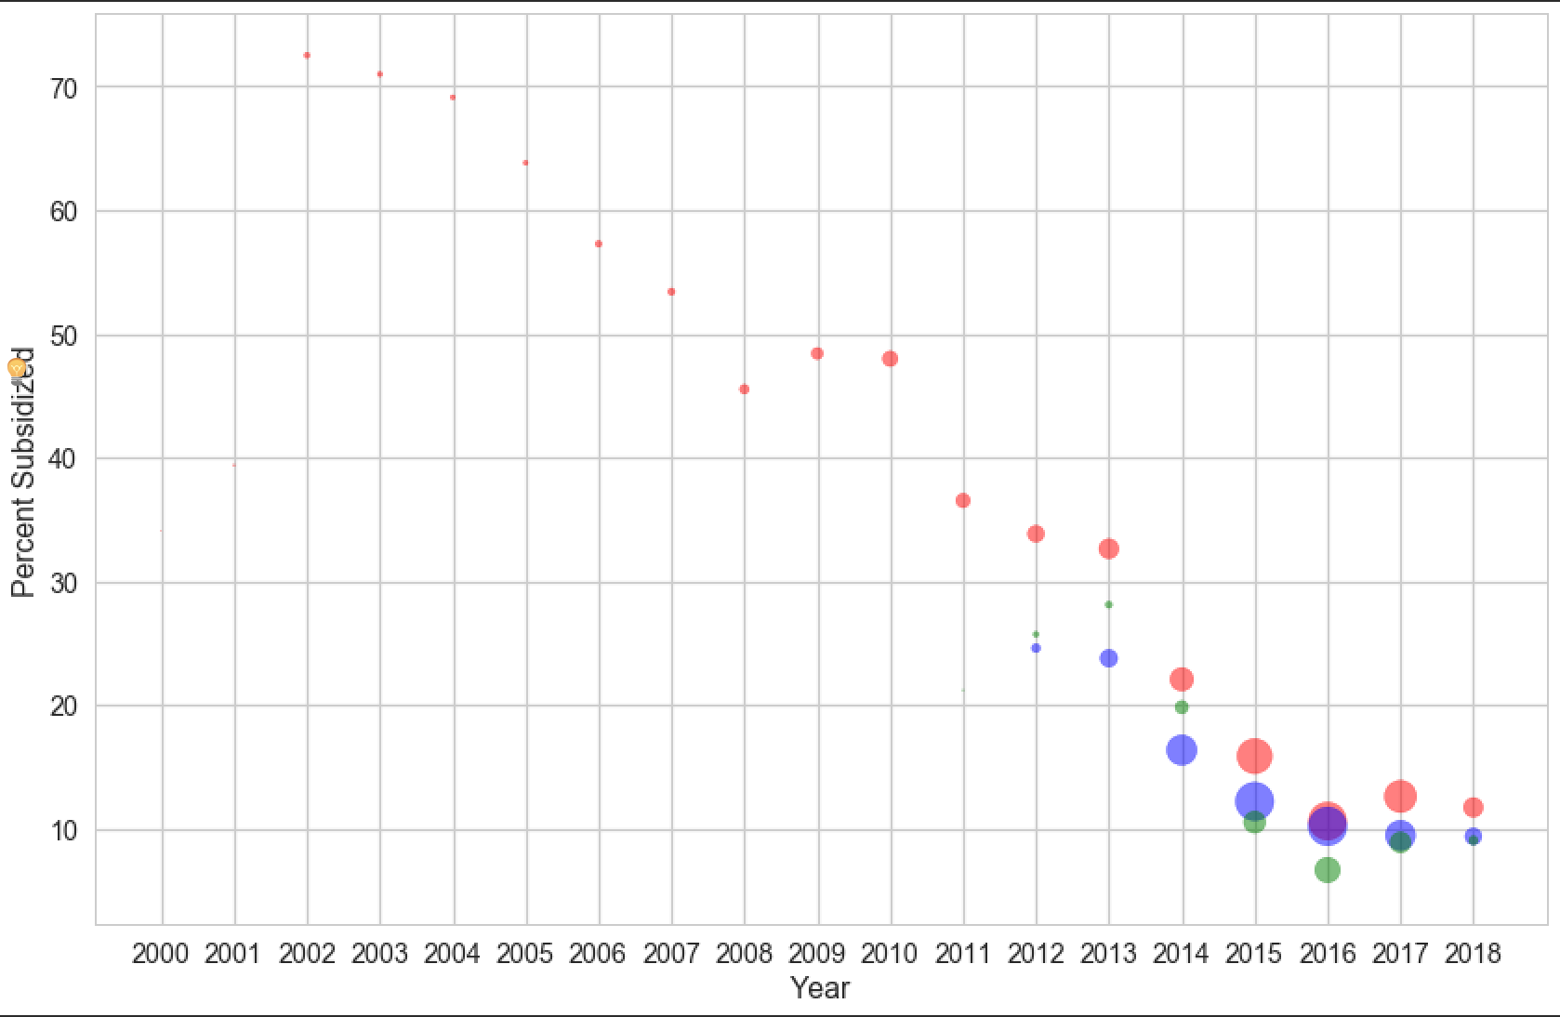

## How do solar adopters finance solar? Do they buy solar, lease it, or use a different financial arrangement?

Starting in 2012 or 2013, when solar adoption began to explode, solar companies introduced new ways to finance solar installation. Prior to then, customers had to outright purchase solar panels to install them – because it’s a 20 to 30-year capital investment, it required a significant down payment. It was not possible to purchase solar without substantial upfront costs. In mid-2013, solar companies started offering zero down lease options, which removed the upfront costs that until then had been a barrier to adoption. Shortly after, they introduced another no down payment financial innovation, known as a power purchase agreement. Under this arrangement, customers did not own solar nor where they responsible for maintenance. They could have solar power installed on their rooftop in exchange for a long term agreement to purchase the power at a fixed price (with no future prices increases) from the solar panels on their roof.

The introduction of these financial innovations occurred shortly before the rapid growth in residential solar installations, suggesting they were a key driver of adoption. It is important to keep in mind, however, that the total cos per unit of solar, known as $/watt, has also been dropping steadily. Before drawing any definitive conclusions, the effect of financial innovations needs to be disentangled from reductions in solar costs.

Figure : Solar Installation by Type of Financial Arrangement

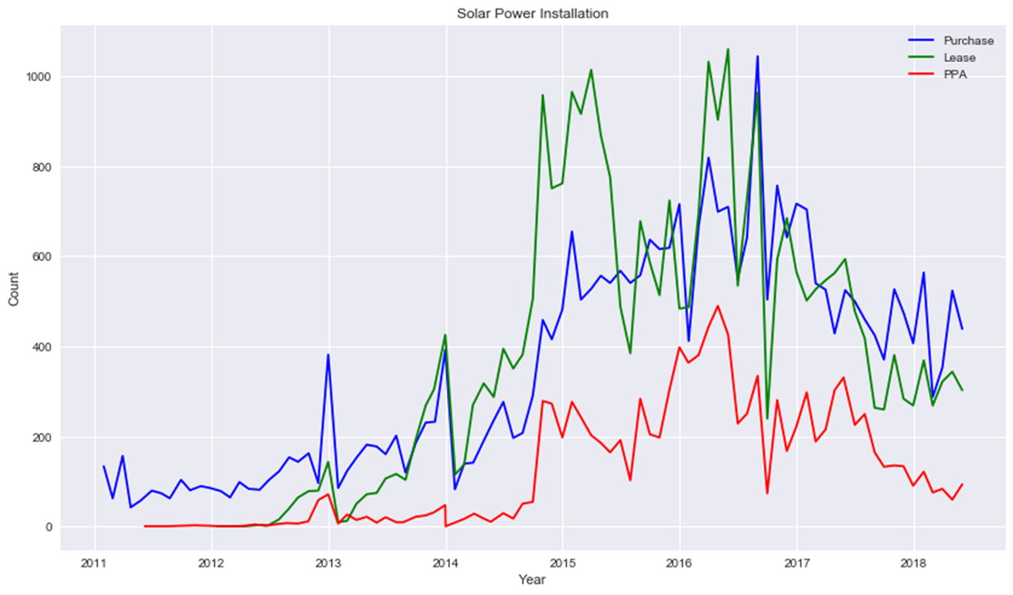

## How are income levels related to solar penetration and how solar is financed?

As part of the assessment, we explored whether income levels in a zip code were related how customers financed solar. A credible hypothesis was that locations with high income would have a higher proportion of customers purchasing solar, rather than using zero-down leasing and power purchase agreement financing options. In other words, we expected lower income areas to disproportionally use zero-down leasing and power purchase agreement options. This hypothesis proved to be wrong.

Figure 10 shows that the distribution of income levels is similar for customers who purchase, lease, or enter into a power purchase agreement for solar.

Figure : Adoption by Income Levels and Finance Type

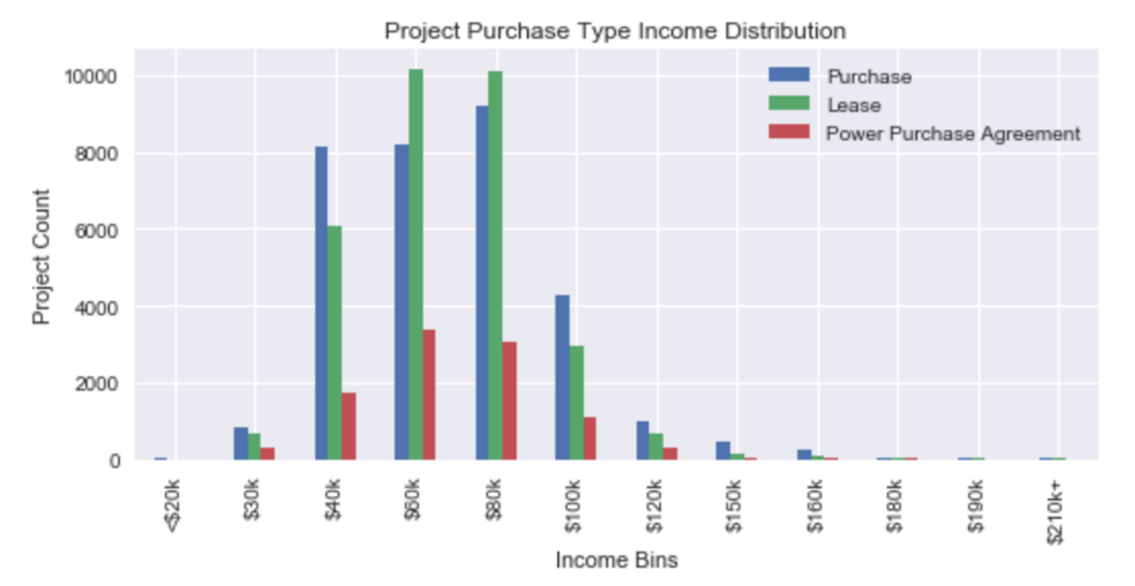

# Key Findings

Table 3 summarizes the research questions of the assessment and the corresponding key findings reached from the data analysis.

Table : Research Questions and Key Findings

|  |  |  |  |  |  |
| --- | --- | --- | --- | --- | --- |
|  | |  | | Research Question | Key Findings |
| Adoption Trends | **1** | | What is the penetration of solar and is it still growing? Are adoption trends for residential and commercial customers different? | | * Residential solar adoption ramped up starting in 2012, peaked in 2016, and is now in decline * Commercial customer adoption continues to grow and is accelerating * While commercial projects are fewer in number, the aggregate amount of solar installed in those projects rivals all residential installations |
| **2** | | How do solar adoption rates vary by location? Is it concentrated in specific locations? | | * Adoption per 1,000 people is highest in the Hudson Valley, Long Island, and the corridor between Ithaca and Syracuse. * Per capita solar adoption in dense areas of New York City is low, likely due to limited rooftop space and lower home ownership rates. |
| Economic and Financial Trends | **3** | | How have the costs of solar changed over time? with and without incentives? | | * The costs of installing solar (equipment + installation) have declined substantially over time. * However, state incentives/discounts for solar installation have also been reduced as the costs of solar have decreased. |
| **4** | | How do solar adopters finance solar? Do they buy solar, lease it, or use a different financial arrangement? | | * Most customers do not busy solar panels. The majority lease them or enter into power purchase agreements (zero-down options). |
| **5** | | How are income levels related to solar penetration and how customer finance solar? | | * Solar installations are not concentrated in areas with high income but instead encompass areas with a wide range of incomes. * Income levels do not appear to play a role in how customers choose to finance solar. |